Lakota Indian Reservation, Pine Ridge, South Dakota
June 9 – 13, 2014
Tamira Smith - Reflective Essay

Black Elk, one of the most famous Oglala Lakota Sioux, once said “And while I stood there I saw more than I can tell and I understood more than I saw; for I was seeing in a sacred manner the shapes of all things in the spirit, and the shape of all shapes as they must live together like one being.” As we ended our week at the Lakota Reservation in Pine Ridge I realized that is exactly how I felt. How could I put down on paper all that I had learned, experienced, and felt to really do it justice? I shall try.
For months I had been so excited about our trip to South Dakota in June. I did not know exactly what to expect and only had all these images running around my mind of what we had been taught about the Native Americans when I was younger. I did not realize that I was going to experience a once in a lifetime opportunity that would totally transform my image of the Lakota people and reinforce my desire to promote change to areas of our world that are underdeveloped and underrepresented.
In order to begin the process of eradicating poverty we must first understand the culture and traditions that influence economic decisions. One of the traditions is that the speaker must have permission from their elders to speak. Therefore, the elders are well respected and their belief that they should be a sovereign nation is a widely held view on the reservation. As a result, the majority of projects and schools on the reservation are not funded by the Federal Government. South Dakota is ranked as the 4th lowest state to receive grant funding which has a negative impact on the outcomes of educational institutions, businesses, and individuals on the reservation. Culture and tradition can greatly effect personal choices and contribute to an extremely low standard of living when a culture does not receive the financial support it needs to promote economic growth and development.
There are many reasons for the extreme poverty on the reservation; however, one major factor supersedes them all—hopelessness and depression that leads to use of alcohol and drugs. Many of the reservation’s people go to White Clay, Nebraska, to buy alcohol and drugs as the reservation is a “dry area.” White Clay sells over 4.5 million cans of beer each year yet not a penny of that revenue returns to the reservation. Therefore, the approximate $4 million earned annually by only a few stores that consists of one small grocery store and 4 liquor stores greatly impacts reservation sufficiency.
Even though these unfair business tactics add to the poverty on the reservation; organizations have been mobilized to find a solution to the problem. Sun Dance Community offers counseling for families who are dealing with alcohol and drug abuse. The Lakota Fund provides over 1,415 employment opportunities. They also have made over $1 million dollars in business loans to provide entrepreneurial opportunities for individuals to gain self-reliance and economic sustainability. There are many more organizations attempting to provoke change in Pine Ridge but as with any traditional economy change takes time.
In order to truly understand the severity of the poverty Lakota Indians face, it is necessary to compare the economy of Pine Ridge to that of a familiar place. The following chart compares statistics between the United States, Tennessee, Greater Memphis area, and the Pine Ridge Reservation. It is immediately evident that Pine Ridge is indeed one of the poorest areas of the United States.

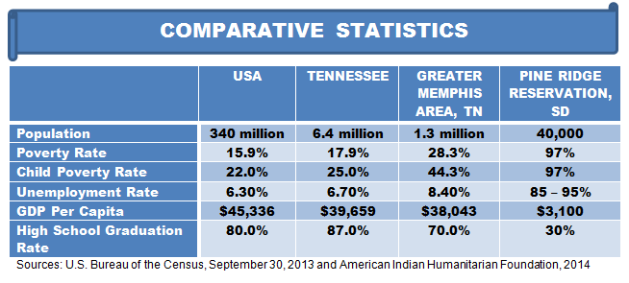
In addition to the above statistics, the Lakota attempted suicide rate is double that of Memphis. They also have lower life expectancy due to poor diet, lack of fitness, and accessibility to medical personnel. The life expectancy of males is 82 years old and 85 for females in Memphis, according to the Memphis Business Journal. The life expectancy for Lakota males is 48 years and 52 years for women. Even though individuals in Memphis have low life expectancy rates on average compared to other parts of the United States, it still surpasses the life expectancy of the Lakota by almost 30 years.
All hope is not lost for the Lakota people; we can affect change in the fight against poverty by bringing resources in to combat several problems. Alcohol and drug counseling is one resource that can turn the fight around. Medical staff that understand the culture, traditions, and are willing to work hand and hand with the Medicine Men can improve health outcomes. Moreover, if people are employed or can run their own business, they will be more effective in supporting the local community. Education is another key element of importance. However, to be effective it is important to respect Lakota Indian traditions, offer classes to strengthen the culture, so that they will not lose their heritage, traditions, or language.
When we arrived in South Dakota and started our drive from Rapid City to Pine Ridge, there were what looked to be endless roads and mountains. Pine Ridge is basically in the in the middle of nowhere—isolated from many towns. Therefore, people living below poverty have no way of escaping even if they want to. The nearest neighbor can live very far away. That made me feel sad for the children thinking how hopeless and trapped they must feel since socialization is important. A lot of people in the community did not have phones which make communication difficult, and some school buses drive hours to pick children up. Many houses did not have electricity, plumbing, or proper insulation which makes it very difficult to deal with the harsh winter climate. However I learned that no matter what your circumstances or economic status are, there is always something to be grateful for and there is hope. The thing that amazed me the most, were the smiles coming from two little boys who still had hope despite living in what most would call an abandoned house with half of the house’s roof caved in.
If no one knows people are suffering, no help will ever come. I will endeavor to share my experiences with others and tell them how they can help. I hope to also start a Kiva Club someday myself, because I believe in the vision of the club to eradicate poverty all over the world. My charity of choice is the Lakota Circle Village and Sacred Circle School. Leonard Little Finger, founder of both, states his purpose as “Lakota Circle Village and Cangleska Wakan Owayawa, are committed to revitalize and stabilize our language, a beautiful and spiritual-based language from which our children can find their own identity as a people. With a better understanding of their own identity, the losses through assimilation will be stabilized. Revitalization of their culture, and language as taught by their elders of what is important and necessary to live a quality life in two worlds, and find the best of both. The school’s intent is to provide a successful language program, and teaching of our heritage and spiritual beliefs to be transmitted to future generations of Lakota.” What a wonderful place that tries to educate the little ones by giving them a sense of who they are culturally, teaching students their native language and providing the only nutritious meal of the day for some of them! Living in a world that has infinite resources there is no reason for anyone to go to bed hungry or live below the poverty line; therefore, I will continue to promote a better world for those suffering every day.

Tamira Smith
Class of 2016
Southwind High School
Memphis, TN

