GLOBAL RESEARCH PROJECT – PART III – SUMMARY POSTER
OBJECTIVE:
To provide an opportunity for student to analyze and synthesize material encountered throughout the Global Research project into a Summary Poster.
STANDARDS:

VOLUNTARY NATIONAL STANDARDS IN ECONOMICS:
Standard 1 – Scarcity
Standard 2 – Decision-Making
Standard 4 – Incentives
Standard 5 – Trade
Standard 6 – Specialization
Standard 7 – Markets and Prices
Standard 10 – Institutions
Standard 15 – Economic Growth

COMMON CORE STANDARDS FOR SOCIAL STUDIES:
CC RH.11-12.2: Determine the central ideas or information of a primary or secondary source; provide an accurate summary that makes clear the relationships among the key details and ideas.

CC RH.11-12-7: Integrate and evaluate multiple sources of information presented in diverse formats and media (e.g., visually, quantitatively, as well as in words) in order to address a question or solve a problem

CC.WHIST.11-12.6: Use technology, including the Internet, to produce, publish, and update individual or shared writing products in response to ongoing feedback, including new arguments or information.

CC WHIST.11-12.8: Gather relevant information from multiple authoritative print and digital sources, using advanced searches effectively; assess the strengths and limitations of each source in terms of the specific task, purpose, and audience; integrate information into the text selectively to maintain the flow of ideas, avoiding plagiarism and overreliance on any one source and following a standard format for citation.

CC WHIST.11-12.9: Draw evidence from informational texts to support analysis, reflection, and research.

TENNESSEE STATE STANDARDS FOR ECONOMICS:
Standard 1.0 – Culture
Standard 2.0 – Economics
Standard 3.0 - Geography
Standard 6.0 – Individuals, Groups, & Interactions

ECONOMIC CONCEPTS:

Scarcity, wants and needs, economic choices, allocation of resources, factors of production, circular flow of economic activity, gross domestic product (GDP), globalization, market vs. traditional economy, role of government and NGOs, population growth and Human Development Index, poverty and distribution of income, economic development, supply and demand, microfinance, and socioeconomic factors.

INSTRUCTIONS: Each group will prepare a Summary Poster of their research on their selected country and their assigned Millennium Development Goal. Posters will be presented to the class. Poster must be created on computer so that it can be loaded to our website and shared with others. You may use the attached poster from Concern Worldwide (USA), Inc. as an example of how your poster could be arranged.
GRADE: This assignment is worth 100 points and will be graded using the attached rubric. NOTE: Summary Poster will count as an exam grade.

ITEMS REQUIRED ON SUMMARY POSTER:

- Heading: MDG Goal Number and Description and Name of Country

- Global Picture – Overview of your MDG on a global scale

- Map of Country and Flag of Country

- Country Facts – include
- Population
- Size
- GDP Per Capita
- Poverty (% living at or below National Poverty Line)
- Human Development Index (HDI)
- Literacy Rate
- Primary School Enrollment Rate
- Access to Clean Water
- Population Living on Less than $2.00 per day
- Life Expectancy at Birth
- Infant Mortality Rate

- Country Challenges – list 4 main challenges that your country faces in order to meet the MDG you selected

- Use of Microfinance to Eradicate Poverty – list 5 current uses of microfinance in your country to eradicate poverty and promote economic growth and development

- Resources – list 3 websites that people can visit to explore more about your country

RUBRIC FOR SUMMARY POSTER
The following rubric will be used to grade the Summary Poster. The total score possible for the entire project is 100 points and is worth an exam grade.
GROUP MEMBERS: ________________________ DATE: ________________
________________________ CLASS PERIOD: ________

 | 5  EXEMPLARY | 3  PROFICIENT | 1  INCOMPLETE | SCORE
DIRECTIONS | Consistently stays focused on  the assigned tasks | Most of the time stays focused  on the assigned tasks | Rarely focuses on the tasks
COLLABORATION | All team members contribute  equally and always respect each other’s efforts | Some team members complete  more work than others and most  respect each other’s efforts | Some or all team members  contributed no work and rarely  respect each other’s efforts
CREATIVITY | Actively seeks and suggests solutions through a variety of  creative means | Seeks creative solutions but struggles without guidance | Does not try to add any creativity to project
RESEARCH | Independently locates many  reliable sources of information | With some help, locates a few  reliable sources of information | Does not locate any reliable sources without guidance
PRESENTATION | Voices are loud, clear, and confident | Voices are at times difficult to hear and understand | Voices are extremely difficult to hear and understand
VISUALS | Visuals clearly follow guidelines and are creatively and clearly displayed | Visuals only follow some of the guidelines and creativity is lacking | No visuals presented
KNOWLEDGE | Demonstrates extensive  knowledge through explanations  and elaboration | Demonstrates adequate  knowledge but lacks detail or  elaboration | Demonstrates unfamiliarity with  content
SCORING: POSSIBLE GRAND TOTAL OF 35 POINTS →

GRADING:

POINTS RECEIVED | EQUIVALENT GRADE
35 | 100
31 - 34 | 95
25 – 30 | 90
20 - 24 | 85
15-19 | 75
10-14 | 70
0-9 | 50
FINAL GRADE RECEIVED:

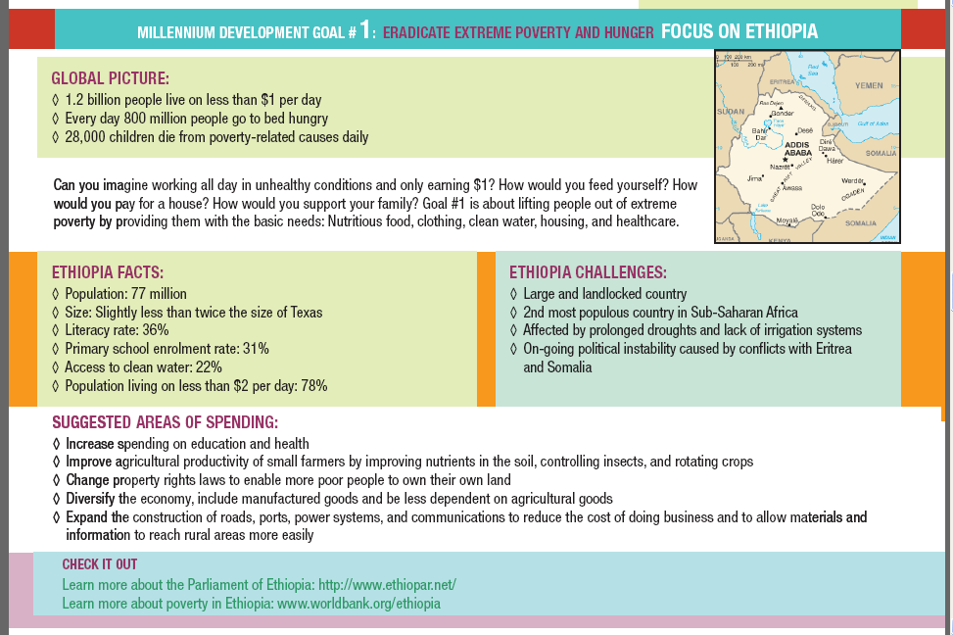
Source: “The Millennium Development Goals – Global Summit Simulation – Educator Handbook,” Concern Worldwide (USA), Inc., www.concernusa.org, 2012.

